

Republic of the Philippines

**CAVITE STATE UNIVERSITY**

**Don Severino delas Alas Campus**

Indang, Cavite

**COLLEGE OF ENGINEERING AND INFORMATION TECHNLOGY**

**Department of Information Technology**

**COLLEGE OF ENGINEERING AND INFORMATION TECHNOLOGY**

**DEPARTMENT OF INFORMATION TECHNOLOGY**

**Accomplishment Report for Undergraduate Thesis**

**First Semester, AY 2020 – 2021**

Name of Researcher/s: **Almadrigo, Lorence V. / Gado, John Philip V.**

Course: **BSIT**

Title of the Study: **“DEVELOPMENT OF E-LEARNING SYSTEM FOR SCIENCE, TECHNOLOGY AND SOCIETY SUBJECT FOR THE STUDENTS UNDER K-12 PROGRAM IN CAVITE STATE UNIVERSITY – INDANG MAIN CAMPUS”**

**I. SHORT BACKGROUND / DESCRIPTION OF THE STUDY**

Education is essential to the progress of any nation’s cultural, political and economic development so effective teaching is critical. Due to the current situation, we are facing every day, we only rely on internet and through online based teachings. E-learning can improve technological way of teaching based on formalized teaching with the help of electronic resources and computer technologies. As the learning progress goes on, we are facing different varieties of problems every day not only time management but also the equipment required.

The system is user friendly so it’s very easy to navigate through simple and clean user interface of the system. It helps the students and instructors to take examinations, activities and access modules easily.

**II. DETAILED ACCOMPLISHMENT REPORT**

**Week 1 – August 27 – 31, 2020**

*Actions Taken*

* *Creating the Graphic User Interface (GUI) of the system for user login and dashboard using Sublime Text editor (free version) and Photoshop V6 for the icons and logos and other background pictures. We also used Ajax components for responsive Login-Ui and Dynamic Dashboard controls and buttons.*

*Accomplishment / Output and Remarks*

* *Complete 20%*

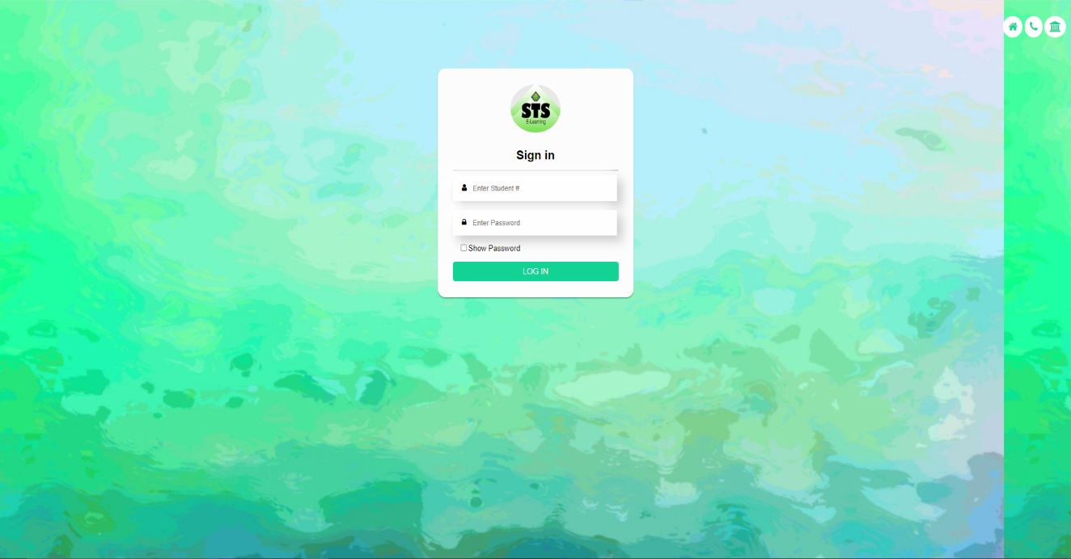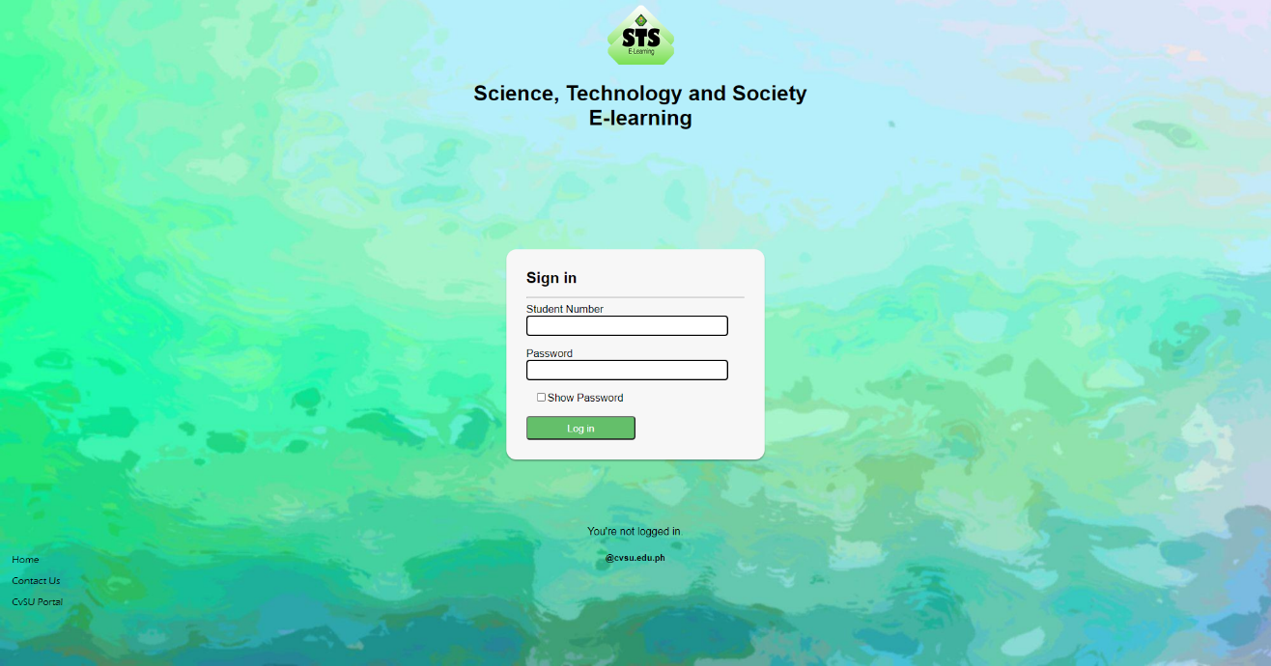

Figure 1.1: User Login Interface

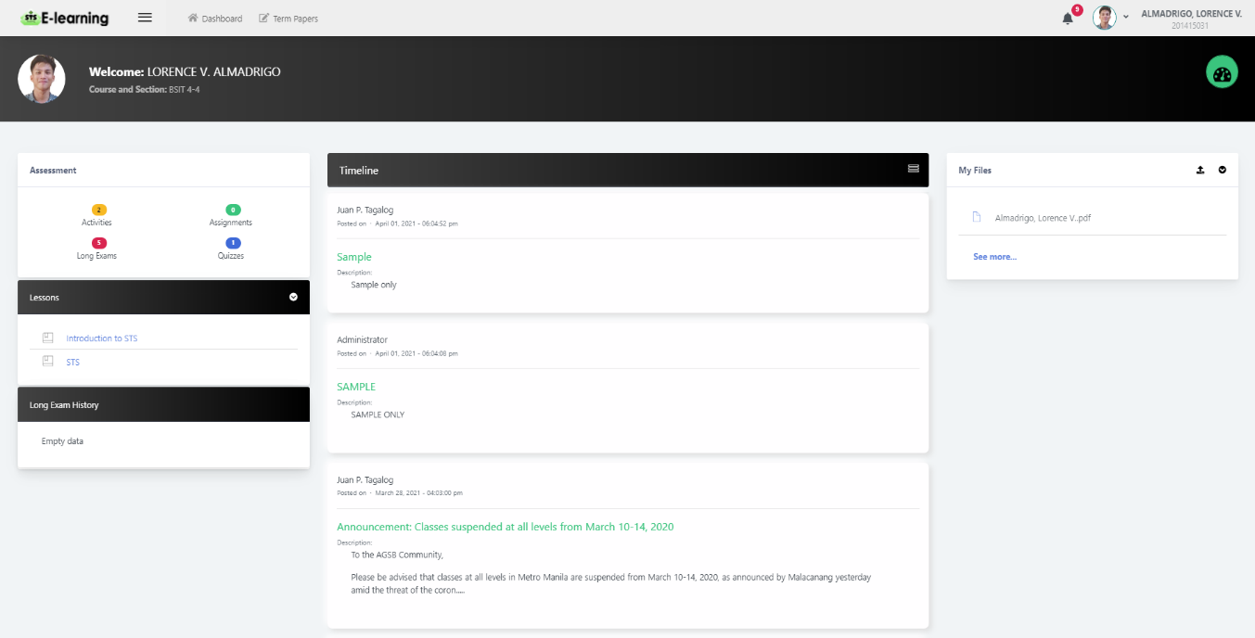User login interface is used for the users to login their accounts. The accounts will be provided by the administrator. Once you enrolled all of your subjects, the admin will automatically add your account to their database. This is to secure that all of the users of this system are enrolled.

Figure 1.2: Student Dashboard

This is the student’s dashboard page. This page shows the navigation controls to Activities, Assignments, Long Exams and Quizzes page. In this page also shows the Lessons Overview and the Announcements posted by the administrators and instructors.

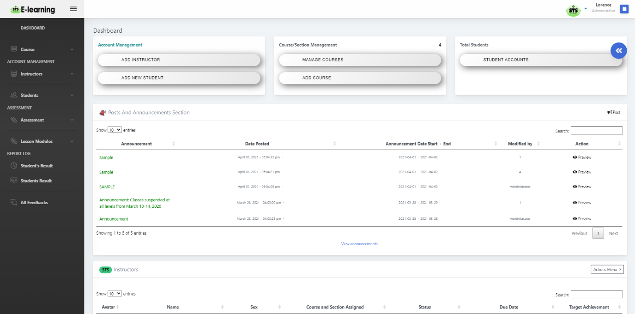

Figure 1.3: Admin Dashboard

Admin dashboard shows the full control on the system. Showing the assessment pages,

Announcements and the account management.

**Week 2 – September 3 – 7, 2020**

*Actions Taken*

* *Creating the Graphic User Interface (GUI) for Account Management Module. For the entire body of the system, we also used Ajax and Java scripts in order to get the best function for every buttons and pages. We used Sublime text editor and Photoshop for creating the whole interface.*
* *Creating database and syntax using XAMPP Control Panel and database management*

*Accomplishment / Output and Remarks*

* *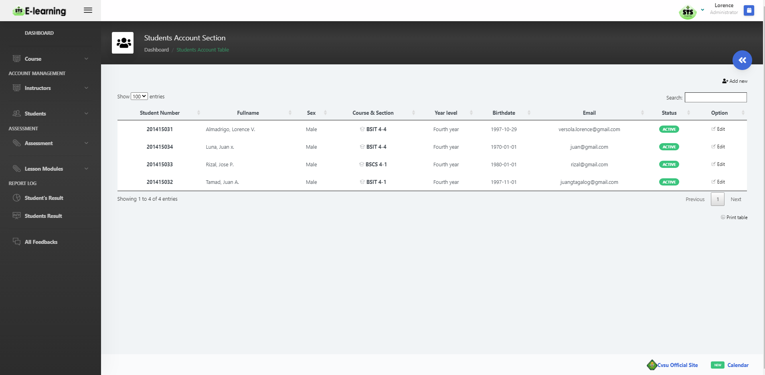 20% complete*

Figure 2.1: Account Management Module (Students)

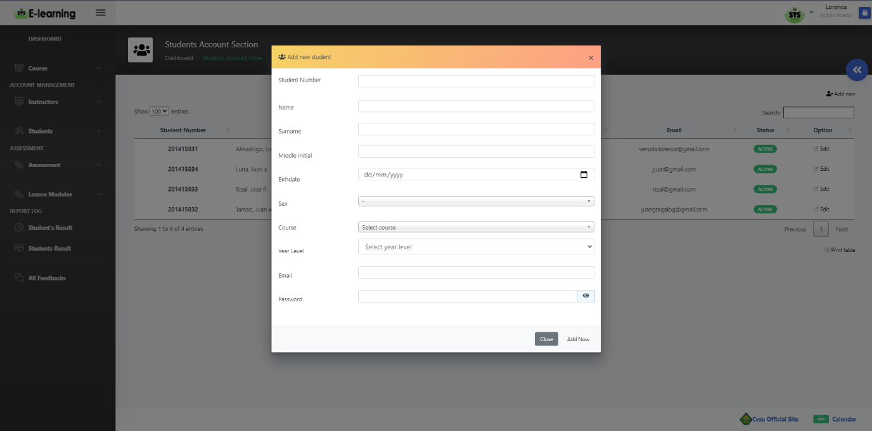

Figure 2.2: Account Management Module (Students)

This is a sample output of Account Management Module for adding students. The administrator has the power to edit students accounts information stored in the database.

**Week 3 – September 10 – 14, 2020**

*Actions Taken*

* *Creating the Graphic User Interface (GUI) for Account Management Module for Instructors. For the entire body of the system, we also used Ajax and Java scripts in order to get the best function for every buttons and pages. We used Sublime text editor and Photoshop for creating the whole interface.*
* *Creating database and syntax using XAMPP Control Panel and database management*

*Accomplishment / Output and Remarks*

* *Complete 30%*

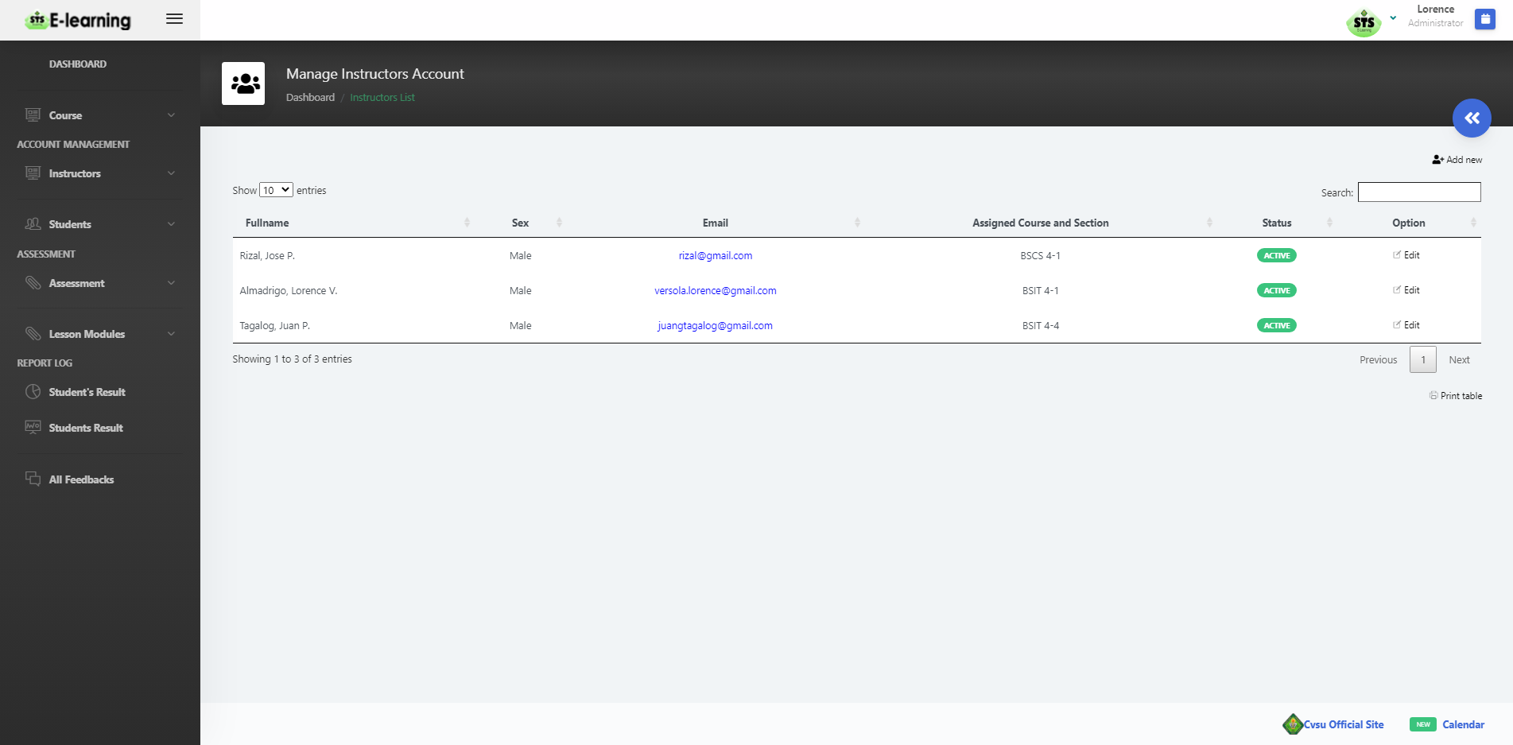

Figure 3: Account Management Module (Instructors)

This is a sample output of Account Management Module for Instructors. This page is the same as the Student’s account management. The administrator has the power to edit all the account information stored in the database.

**Week 4 – September 17 – 21, 2020**

*Actions Taken*

* *Creating Graphic User Interface (GUI) for Announcement Module. Using sublime text for coding and Java script for functions and XAMPP control for database management.*

*Accomplishment / Output and Remarks*

* *Complete 40%*

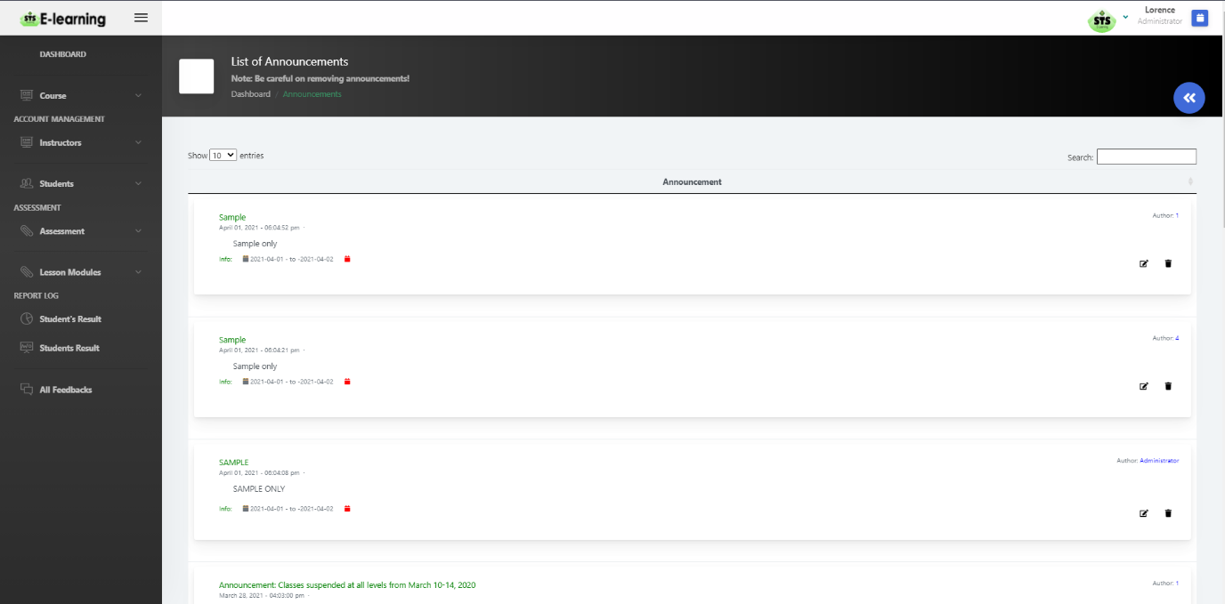

Figure 4: Announcements Module

This module shows the announcements posted by the administrators and can be viewed by the users on their announcement page on their accounts.

**Week 5 September 24 – 30, 2020**

*Actions Taken*

* *Creating Graphic User Interface (GUI) for Assessments Module. Starting for making the Lesson Module. Using Sublime Text editor, we manage to code the entire page for the Lessons and storing data into XAMPP control database panel.*

*Accomplishment / Output and Remarks*

* *Complete 50%*

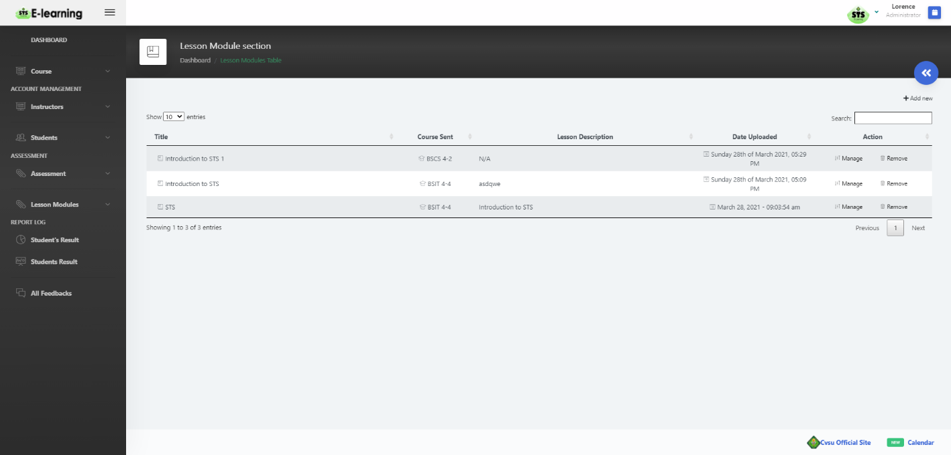

Figure 5.1: Lesson Module (Administrator’s View)

Figure 4: Lesson Module

This is a sample output for Lesson Module on administrator’s view. This module is consisting references for the students. These references can be uploaded by the administrator and instructors.

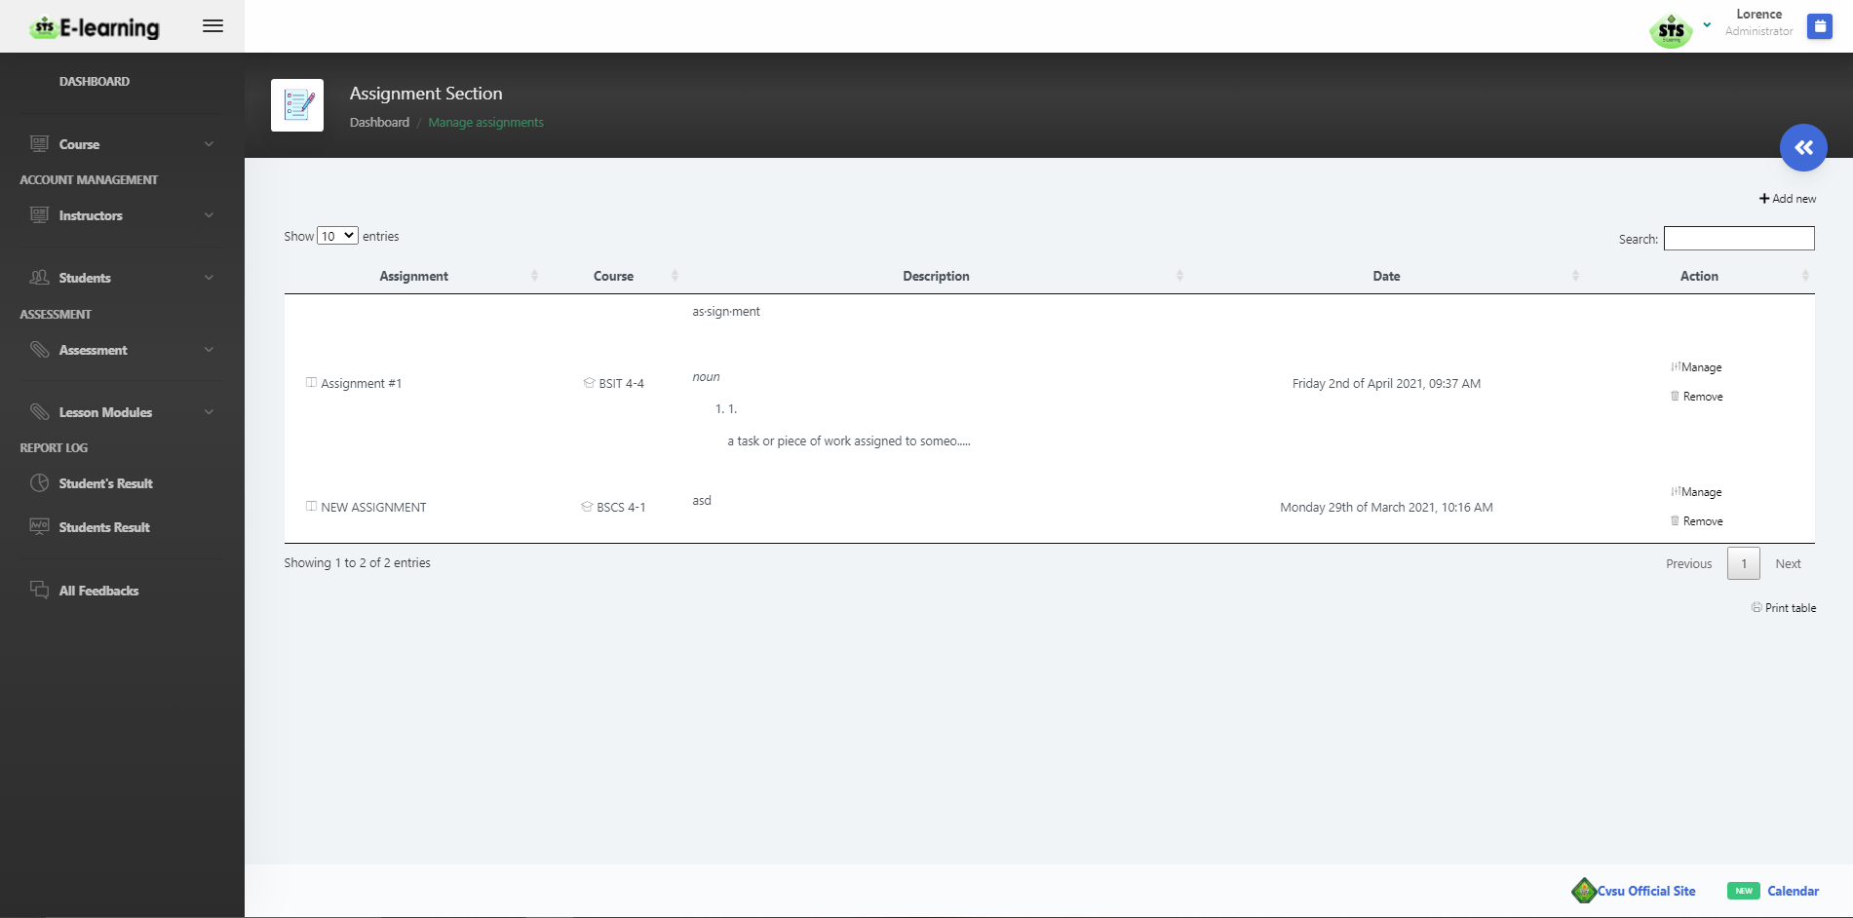

Figure 5.2: Assignment Module (Administrator’s View)

Figure 5.2: Assignments Module (Administrator’s View)

This is a sample output for Assignments Module on administrator’s view. This module is consisting of all the references that a student needed. These references can be uploaded by the administrator and instructors only. Students can only view the uploaded lessons.

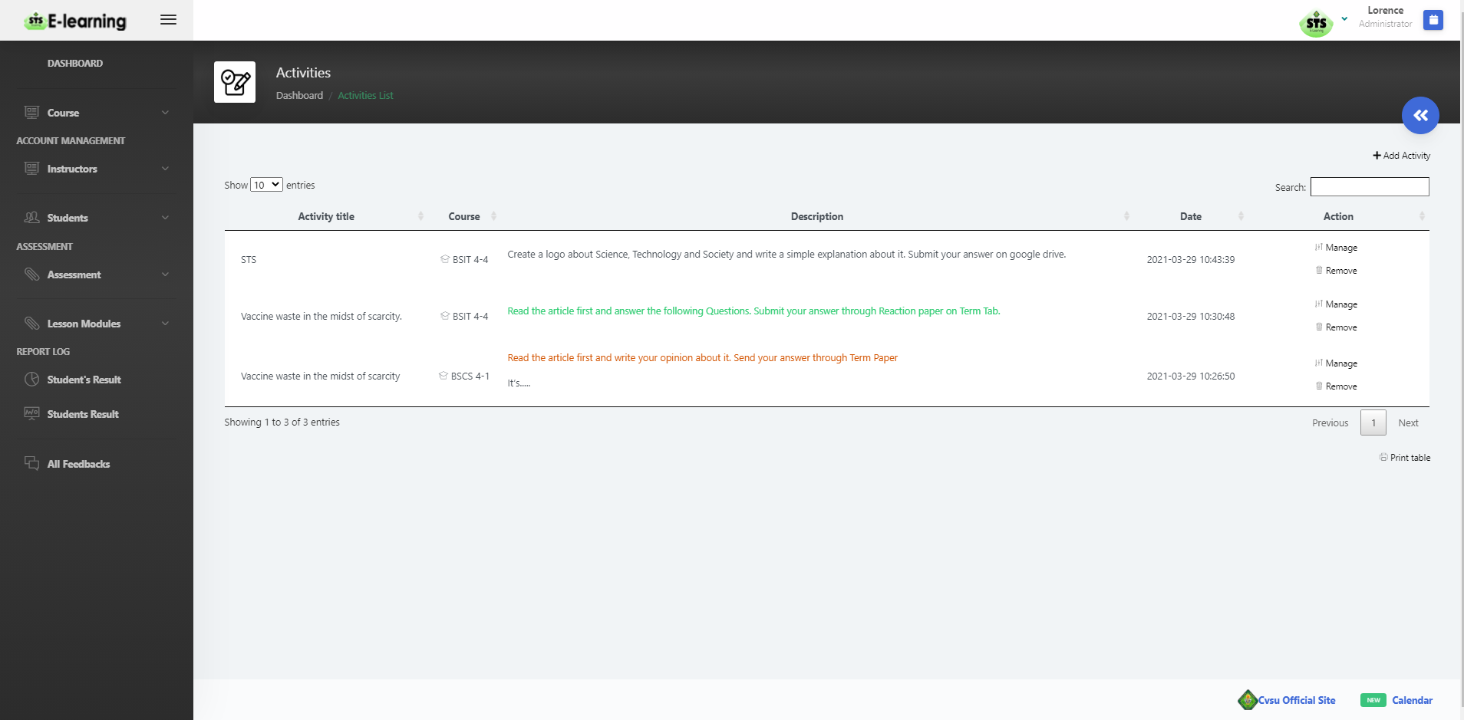

Figure 5.3: Activities Module (Administrator’s View)

This figure shows activity table sample.

**Week 6 – October 2 – 6, 2020**

*Actions Taken*

* *Creating the Graphic User Interface (GUI) for Assessments Module Continuation for Exam and Quizzes modules and Report Module. Using sublime text for coding and Java script for functions and XAMPP control for database management.*

*Accomplishment / Output and Remarks*

* *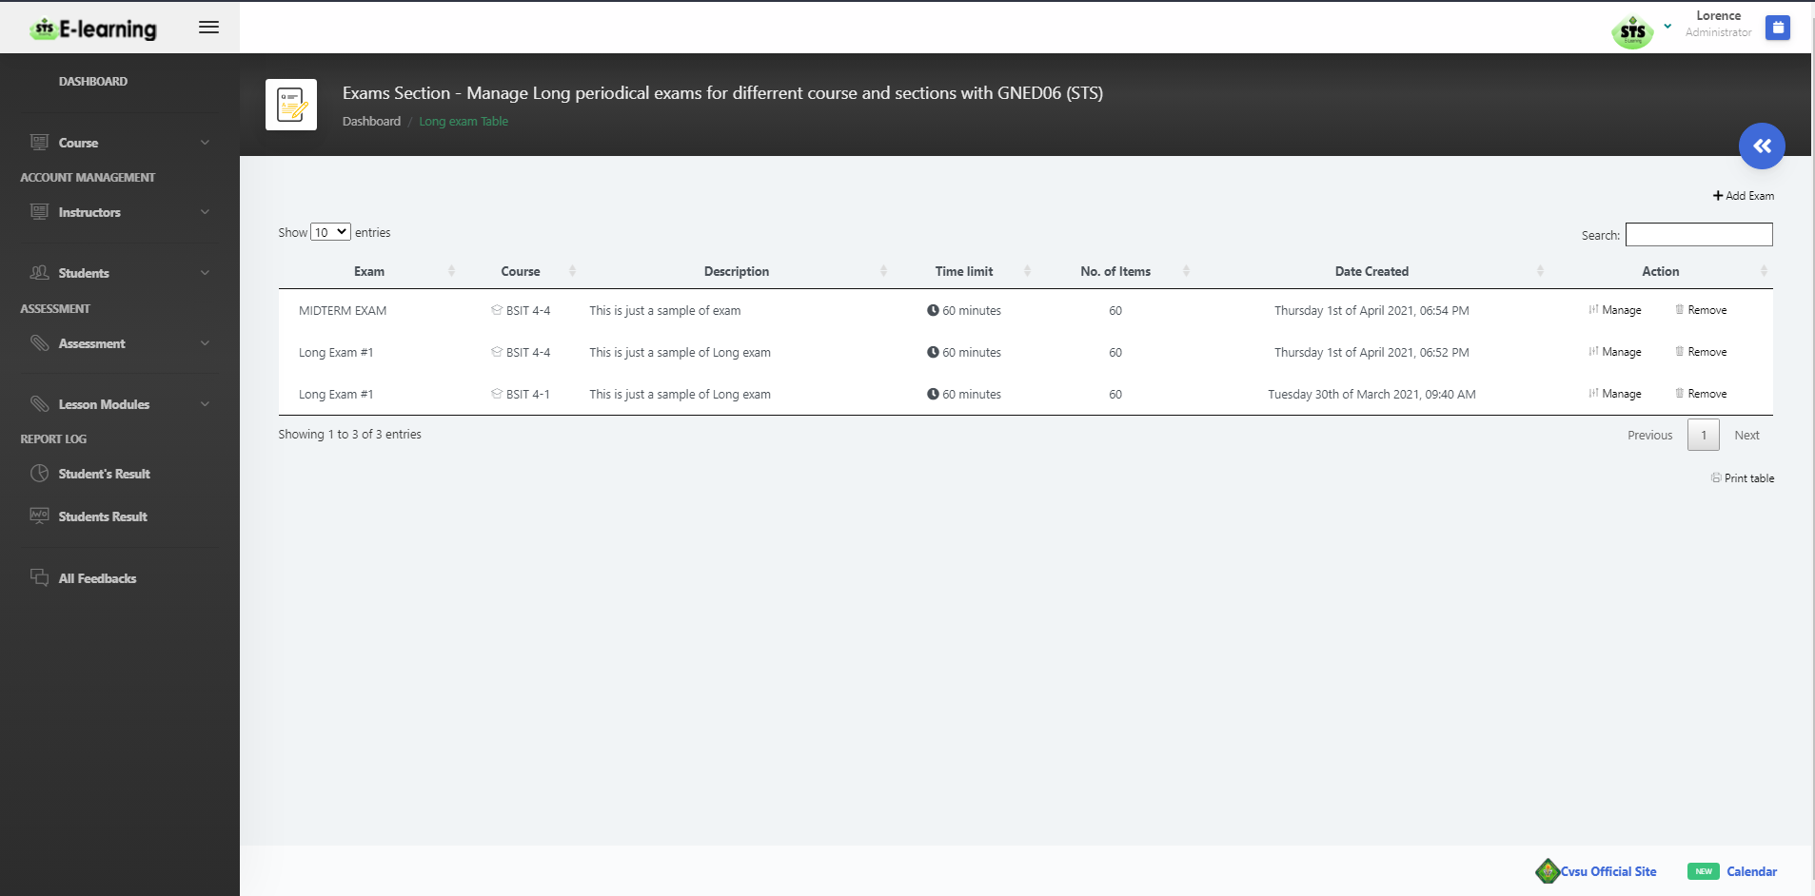Complete 60%*

Figure 6.1: Long Exam Module (Administrator’s View)

This figure shows the added Exam for the students. It shows the Exam name, course which where it is uploaded, the time limit and number of items.

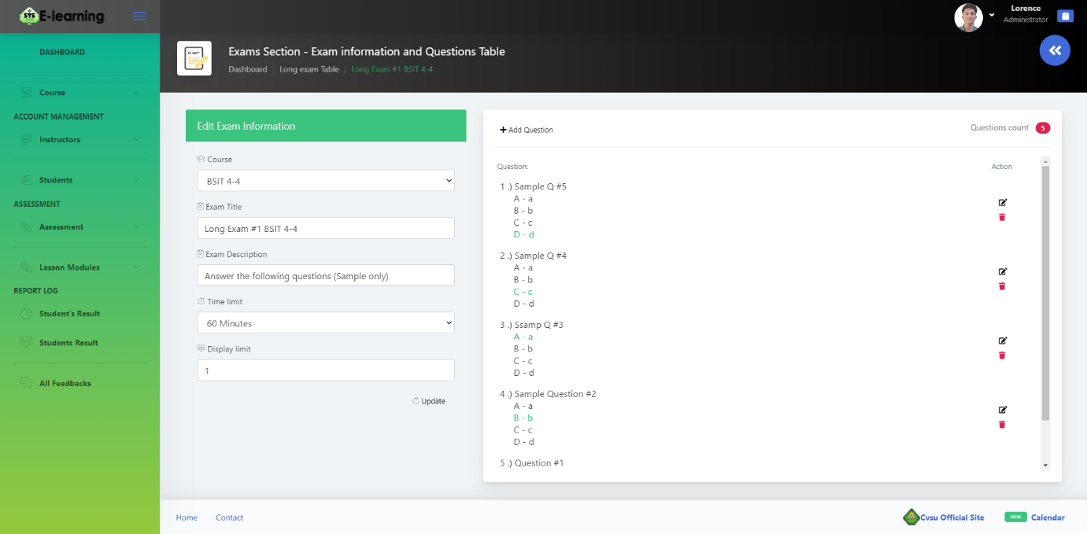

Figure 6.2: Long Exam Module (Administrator’s View)

This is a sample questions for the exams, the administrator has the power to add and delete questions and update the exam information.

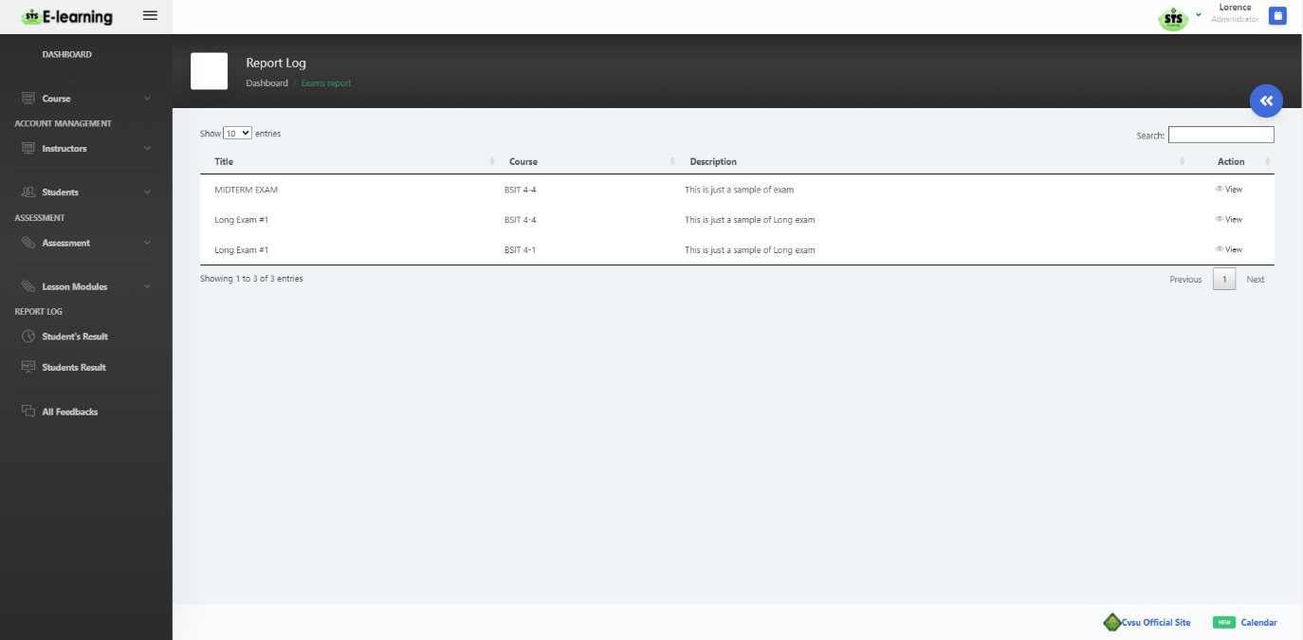

Figure 6.3: Report Module

This shows a sample of report module, it shows that the student’s result on its exams and activities.

**Week 7 – October 9 – 13, 2020**

* From October 9 to 31, we can't start our system because we have a problem in our equipment. We can't buy a new parts because we are lack of money to buy a new one.

**Week 8 – November 16 – 20, 2020**

* From November 1 - 19, we didn’t do the other modules because the laptop that we are using for coding was not working or crushed. From November 16, we bought a part for a cheaper price and start working in our system.

**Week 14 – December 7 – 12, 2020**

* By this week, we still working in our system but in the unlikely event, the pc that we are also using for coding was crushed and we are now finding a way to fix it.

**Week 18 – December 25 - 29, 2020**

*Actions Taken*

* *Creating the Graphic User Interface (GUI) for Students Interface Assessment Module. In this progress, this shows all the page on Student’s interface. For the entire body of the system, we also used Ajax and Java scripts in order to get the best function for every buttons and pages. We used Sublime text editor and Photoshop for creating the whole interface.*

*Accomplishment / Output and Remarks*

* *Complete 70%*

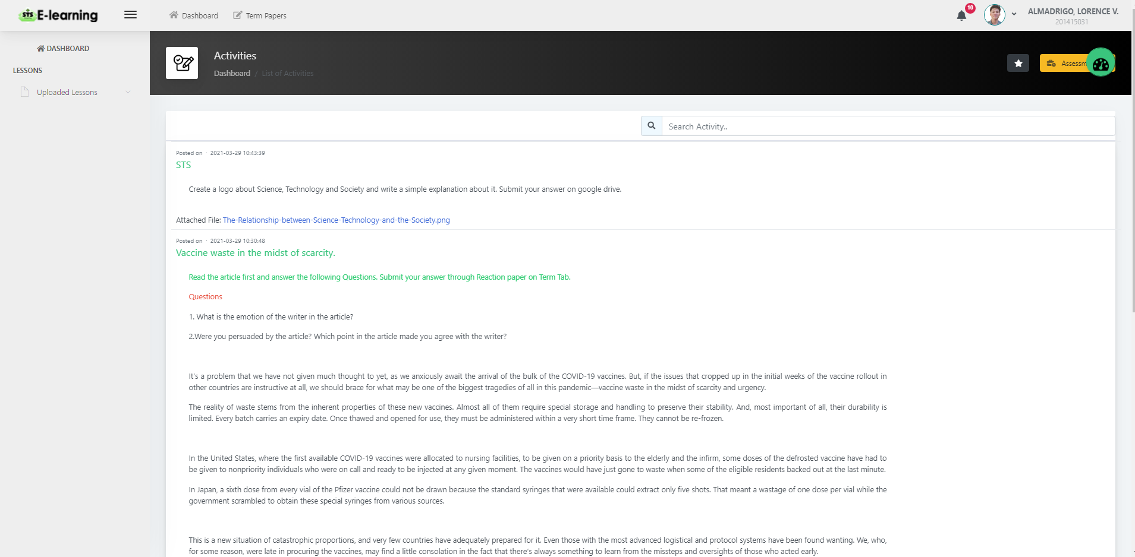

Figure 7.1: Activity Module

This figure shows the activities uploaded by the instructor and administrator.

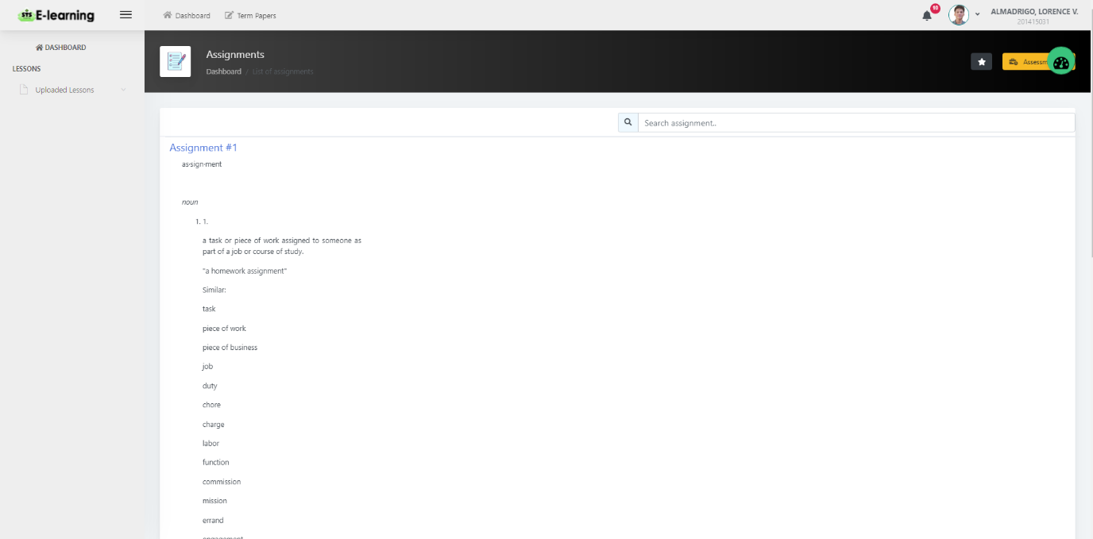

Figure 7.2: Assignments Module

All the assignments uploaded shows in this page in student’s interface.

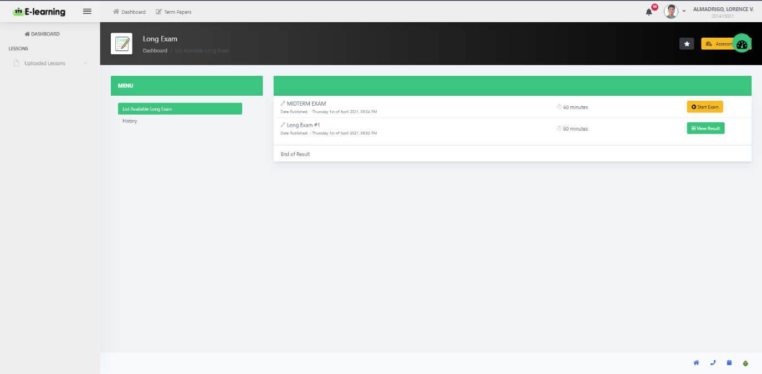

Figure 7.3: Long Exam Module

This table shows the uploaded exams for the students.

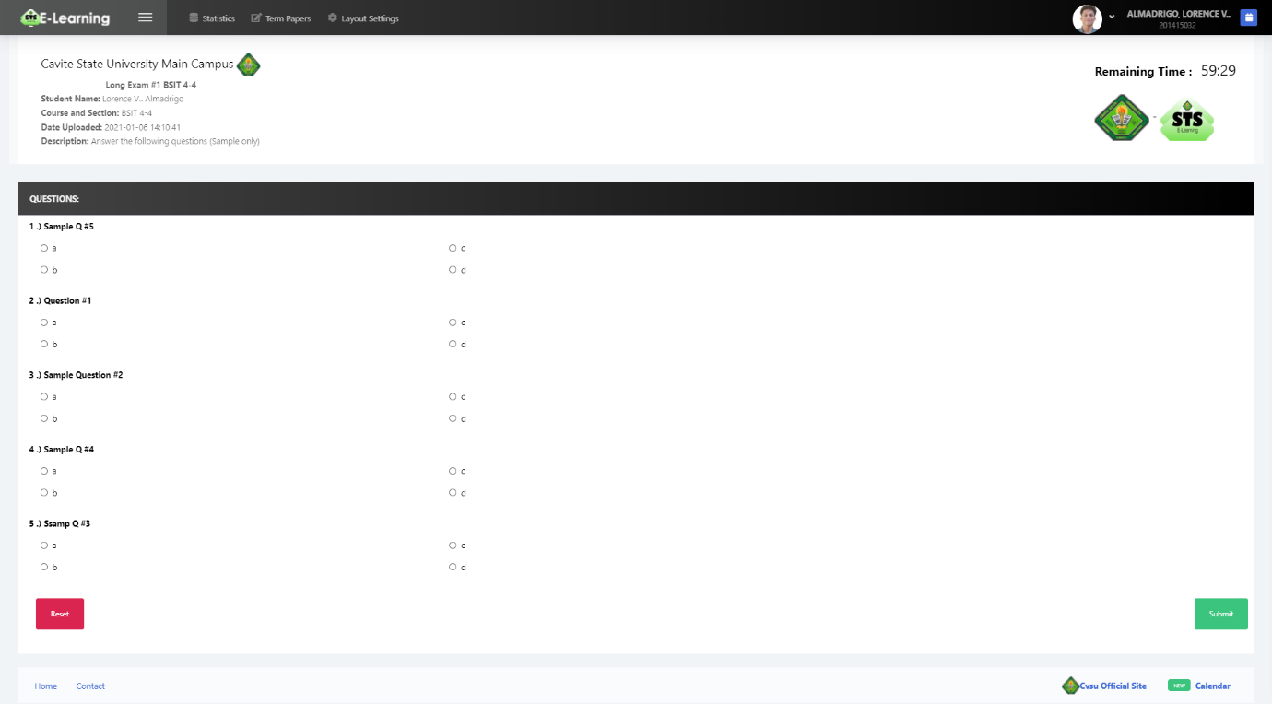

Figure 7.4: Long Exam Module (Exam)

In this figure shows on the spot online exam for the students. It shows the time limit and the questions. The overall questions is randomized whenever the students start to take the exam, this is to avoid copying each other’s answer even if it is taking online. After the exam and if the student submitted it’s answer, the system will show all their answers if it is wrong or correct and it will show their over all score.

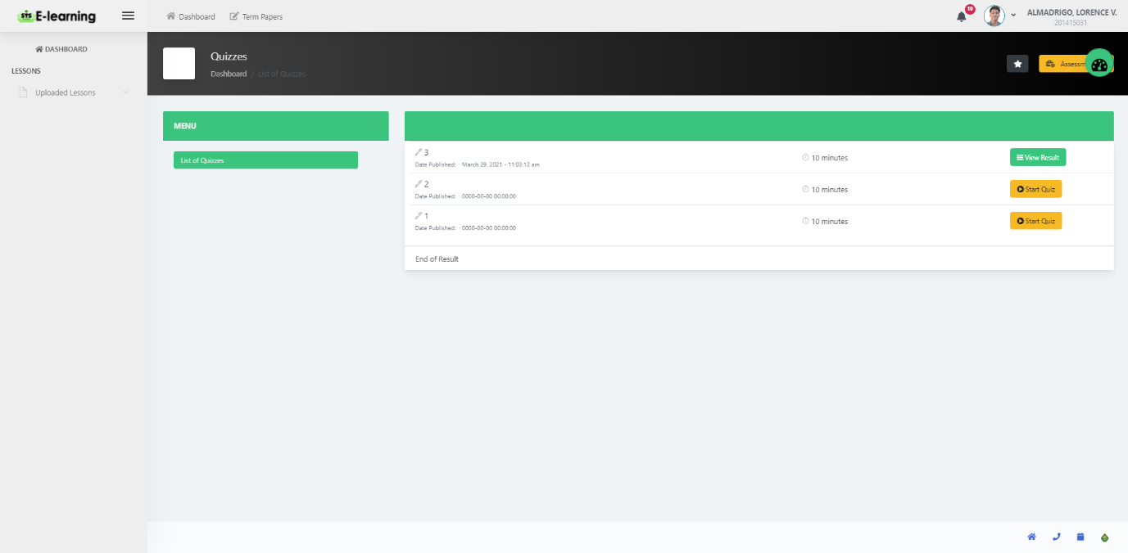

Figure 7.5: Quizzes Module

This figure shows same as the long exam module because it has the same table design and same examination page.

**III**. **BRIEF SUMMARY OF THE COMPLETION OF THE SYSTEM**

|  |  |  |
| --- | --- | --- |
| **RESEARCH OBJECTIVES** | **ACTIONS TAKEN** | **PERCENTAGE OF COMPLETION** |
| 1. Identify problems encountered both by the students and the research coordinators using surveys and interviews | **Interviewee**: Students of CEIT that taking Science, Technology and Society (GNED06) subject.  Questions and Responses  **Question 1: What are the tools that your instructor used in their discussion?**  **Summary Answer:** Most of the respondents said that their instructors usually use projectors, and printed lectures for their discussion, whiteboard, blackboard.  **Question 2: How can you ask/request for materials/notes from the instructor?**  **Summary Answer:** Most of the respondents said that they ask their instructor through messenger  **Question 3: Is the class size affects you in learning the subject? How?**  **Summary Answer:** Most of the respondents answered Yes. Whenever they were conducting their discussion time, they are lacking on sitting chairs especially when their room is not that big enough.  **Question 4: Do you have any references in STS?**  **Summary Answer:** Most of the respondents said that they have learning references in the STS subject.  **Question 5: Do you have sufficient materials like books for STS subject? If your answer is No, on what way do you find for another reference material for reaction papers and lessons?**  **Summary Answer:** According to the respondents, they have sufficient materials for their subject.  **Question 6: What are the materials prepared/provided of your instructor?**  **Summary Answer:** Most of the respondents said that their instructor provided printed handouts and projected lectures in their discussion.  **Question 7: In what way does your instructor conduct their class although they’re not available to attend the class?**  **Summary Answer:** Most of the respondents said that their instructors messaging them to have their advance reading to the lesson that has been skipped.  **Question 8: How can your instructor disseminate (spread) any announcement/reminder in class?**  **Summary Answer:** Most of the respondents said that through group chats and reminding the officers in their class.  **Question 9: Do you think that E-Learning will help you on your study? If yes, how?**  **Summary Answer:** Most of the respondents answered that through E-Learning, it helps them to easily understand the topic or lesson.  **Question 10:** What are the activities provided by your instructor to assess the skills and performance of each student?  **Summary Answer:** Most of the respondents said that reporting, group activities applying what have we learned on a certain subject.  **Interviewee:** Instructors of Department of Biology Sciences handling Science, Technology and Society (GNED06) subject.  **Question 1: What does Science, Technology and Society all about?**  **Summary Answer:** According to the instructors, the Science, Technology and Society subject is about science and technology can do and how this affects the society. The concepts, history and importance of science; as well as the application as technology.  **Question 2: How many students per section taking Science, Technology and Society (GNED 06) subject?**  **Summary Answer:** According to the instructors, approximately 40 students per section are the students taking Science, Technology and Society (GNED 06) per section.  **Question 3: How many instructors handled the Science, Technology and Society subject?**  **Summary Answer:** According to the instructors, there are 13 instructors teaching Science, Technology and Society (GNED 06).  **Question 4: Is there enough reference materials for the STS subject during the traditional method of discussions?**  **Summary Answer:** Most of the instructors said that they all have the references like books that they need for Science, Technology and Society (GNED 06).  **Question 5: Does the students have a sufficient materials and references during class sessions?**  **Summary Answer:** Most of the instructors said yes and they are encouraging their students to buy a book as their reference.  **Question 6: What are the activities do you prepare to assess the skills and performance of each student?**  **Summary Answer:** According to the instructors, they provide take home activities, quizzes and reaction papers.  **Question 7: How do you evaluate the grades of the students in checking their activities?**  **Summary Answer:** Most of the instructors checked their student paper works manually.  **Question 8: In what way do you present your lessons during class hour? What materials are you going to use?**  **Summary Answer:** Most of the instructors use power point presentation.  **Question 9: How do you disseminate announcements or reminders in your classes?**  **Summary Answer:** Most of the instructors give their announcements through Facebook pages, group chat and Google classroom.  **Question 10: Do you give accurate announcement for the class even you’re able to meet them?**  **Summary Answer:** Most of the respondents said that they’re not that accurate on announcements for their students specially when they’re on a rush. | 100% Completed |
| 1. Analyze the problems through fishbone diagram |  | 100% Completed |
| 1. Design and develop a module that will 2. lessen the time consumed in monitoring he researches of the college 3. minimize the inconsistency of the data entry 4. help the students in tracking the thesis/study title if it is already existing or not. | * ***Account Management Module* –** In this section, where users can create an account to enter and access different features of the program. Each module offers three forms of level of access rate – the administrator, the instructors and the students. The administrator has the priority level of access which can add instructor, add student, update every profile and change the passwords of the registered students and instructors' accounts. Only students can be added their own profile updated and their password changed. The students may only update their profile and change their password. For the purpose of security, the administrator manages all the files and profiles inserted into the system database. (See Figure 2.1, 2.1 and 3) * ***Assessment Module* –** In this module, it acts as an assessment of the students' instructors. This module includes all quizzes, activities and assignments. The teachers and administrator can only add, edit, delete and view these and the students will take the assessment. The type of the quizzes is fill in the blanks, enumeration and multiple choices. (See Figures 5.1, 5.2, 5.3, 6.1, 6.2, 7.1, 7.2, 7.3, 7.4 and 7.5) * ***Lesson Module* –** This module includes all of the class references and lessons that are added to the program. The lessons are supervised by the administrator and instructors when adding modules, the administrator and instructors are the one who manages the uploading of the lesson data. The lessons uploaded that include multimedia forms, such as videos, photographs, texts and audios viewed by the students. (See Figure 5.1) * ***Announcements Module* -** This module contains administrator and teacher updates and reminders for each of the students and sections that they manage. (See Figure 4) * ***Report Module* –** Through this, it can easily project various collected data from all the users and all the activities. In this module, report logs can be generated for the administrator, the instructors and the students. All lists of students enrolled in the subject, list of instructors handling STS and student grades can be downloaded and printed by administrator, and the instructor can only print out the list of the students and grades of the students they are handling. | Week 2 and 3 -  30% Completed  Week 5 – 50% Completed and on Week 18 – 70% Completed  Week 5 - 50% Completed  Week 4 – 40% Completed  Week 6 – 60% Completed |
| 1. Test the system functionality using unit testing and system testing. | **Account Management Module Functionality:**   * Allows to create accounts: * Allows to edit and view account information: * Allows to disable accounts: | 100%  80%  0%  100%  100%  60%  100%  90%  80%  80%  100%  60%  50%  0% |
| **Assessment Module Functionality:**   * Allow to take exams: * Allow to take quizzes: * Allow to view activities: |
| **Lesson Module Functionality:**   * Allow to view uploaded lessons: * Allow to upload media files: |
| **Announcement Module Functionality:**   * Allow to upload announcements: * Allow to upload media files: * Allow to delete announcements: |
| **Report Module Functionality:**   * Able to print reports: * Allow to view all datas: * Can view development records: |
| 1. Evaluate the system using ISO 9126 | Due to the current situation, students and teacher are not required to conduct system evaluation for safety reasons. |  |

**IV. INSIGHTS**

We have a lot of experiences and developments when the Covid-19 pandemic started. We experience so many problem in making our system. But in the end, we managed to work on it. This proposal was conducted to help the students in terms of communication and also to lessen the work of teachers. This is very effective today due to the pandemic. Teachers can send references, modules and exams without the physical interaction with the students. For the students, they can have the references and modules anytime, as long as they have internet or mobile data.

Prepared by:



**LORENCE V. ALMADRIGO**

**JOHN PHILIP V. GADO**

Recommending Approval:

**AIZA E. BIHIS RACHEL O. RODRIGUEZ**

Thesis Adviser Technical Critic

**GLADYS G. PEREY EDWIN R. ARBOLEDA, PhD**

Unit Research Coordinator College Research Coordinator

Approved by:

**DAVID L. CERO, PhD**

College Dean